**APPLICATION DESIGN DOCUMENT**

|  |  |  |  |
| --- | --- | --- | --- |
| **Version Number** | **Date** | **Author** | **Notes** |
| 0.1 | 06-Aug-2022 | Krishna Vollala | Initial document |
|  |  |  |  |

Table Contents

**OVERVIEW** 3

**PURPOSE** 3

**BUSINESS & FUNCTIONAL SPECIFICATIONS** 3

**ARCHITECTURE DIAGRAM** 3

**End to End Data Flow** 4

**Azure services information** 4

**ADLS Path:** 4

**Dedicated SQL pool stored procedures:** 5

**Azure Analysis Services connection string:** 5

**Power BI Models:** 5

**1.** **SAN Driver:** 5

**2.** **SAN Inventory Dashboard:** 6

**3.** **SAN Revenue Recognition Dashboard** 7

**4.** **SAN TIM Dashboard** 8

**5.** **SAN USA+CAD+Intl Wholesale Daily Shipments** 8

# **OVERVIEW**

This document describes the overall architecture of the system which has the end to end data flow information.

# **PURPOSE**

This document describes the overall architecture of the system which has the end to end data flow information.

# **BUSINESS & FUNCTIONAL SPECIFICATIONS**

The overall system architecture will include the following functionalities:

1. Ingest data into Azure ADLS in csv format.
2. Use Dedicate SQL Pool stored procedure to read data from ADLS and store the results in Azure cubes.
3. Consuming the curated data using Power BI.

# **ARCHITECTURE DIAGRAM**

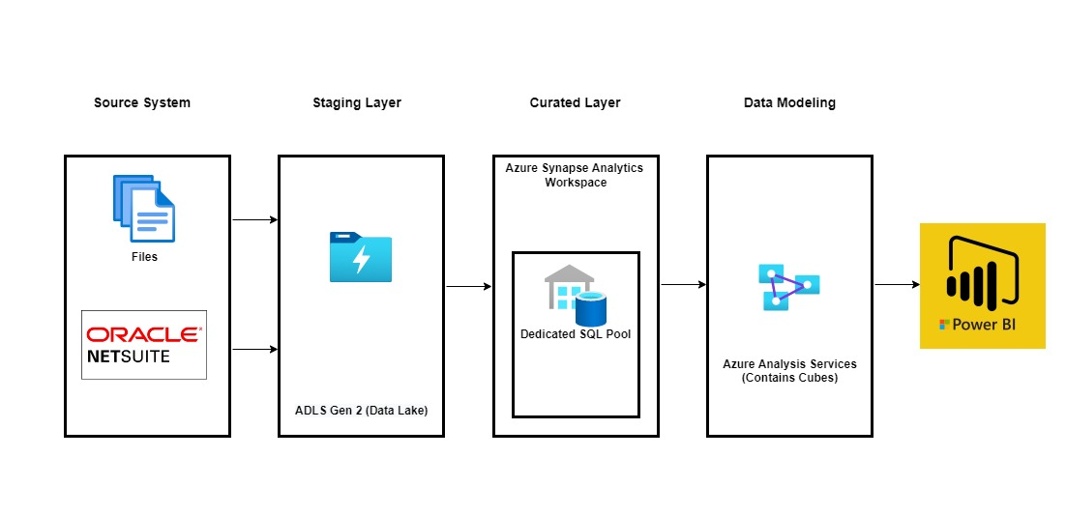

Above architecture contains below technologies: -

**Source System:** Data is coming to Azure ADLS in csv format from Oracle NetSuite

**Azure ADLS:** This will be used as staging layer to initially keep the data files in Azure cloud.

**Curated Layer:** Dedicated SQL pool

**Data Modelling:** Azure Analysis Services.

**Data Visualization:** Microsoft Power BI

# **End to End Data Flow**

Below are the steps involved during the data ingestion and data consumption at various layers.

**Step 1:** Data comes to Azure ADLS in csv format from Oracle NetSuite and other source systems.

**Step 2:** Csv data from ADLS will be loaded into Dedicated SQL Pool staging tables via DataBricks Notebook.

**Step 3:** Using stored procedures, staging tables data will be loading into corresponding target tables using some transformations like casting the datatypes and length according to the business need.

**Step 4:** Target tables data again loaded into Cubes in Azure Analysis Services for data modelling.

**Step 5:** Power BI will consume the cubes and according to the Business user requirement interactive reporting and data visualizations will be developed.

**Step 6:** Above created reports, visualizations and dashboards will then be published to Power BI Services

# **Azure services information**

## **ADLS Path:**

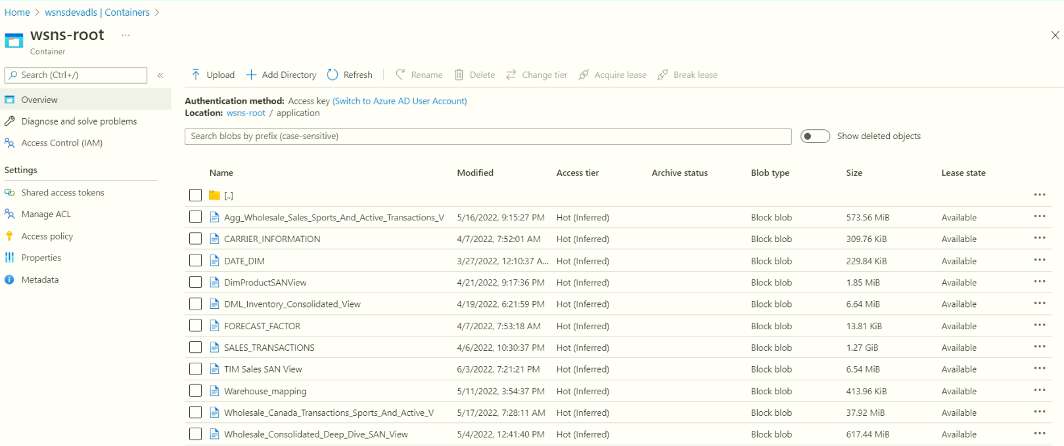

## **Dedicated SQL pool stored procedures:**

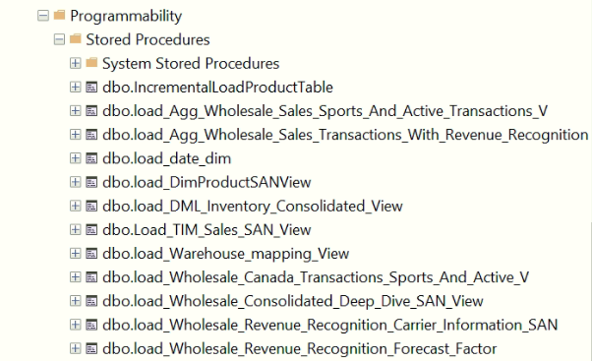

## **Azure Analysis Services connection string:**

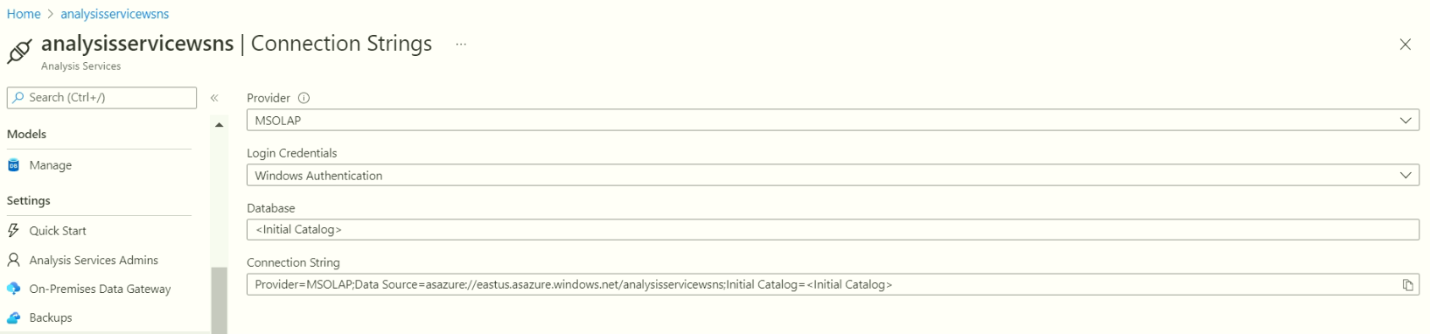

## **Power BI Models:**

### **SAN Driver:**

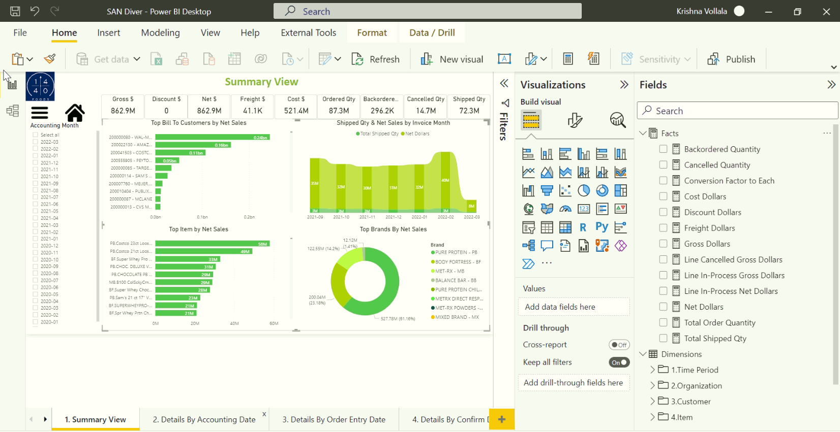

**Pages:**

1.Summary View

2.Details By Accounting Date

3.Details By Order Entry Date

4.Details By Confirm Date

Glossary

### **SAN Inventory Dashboard:**

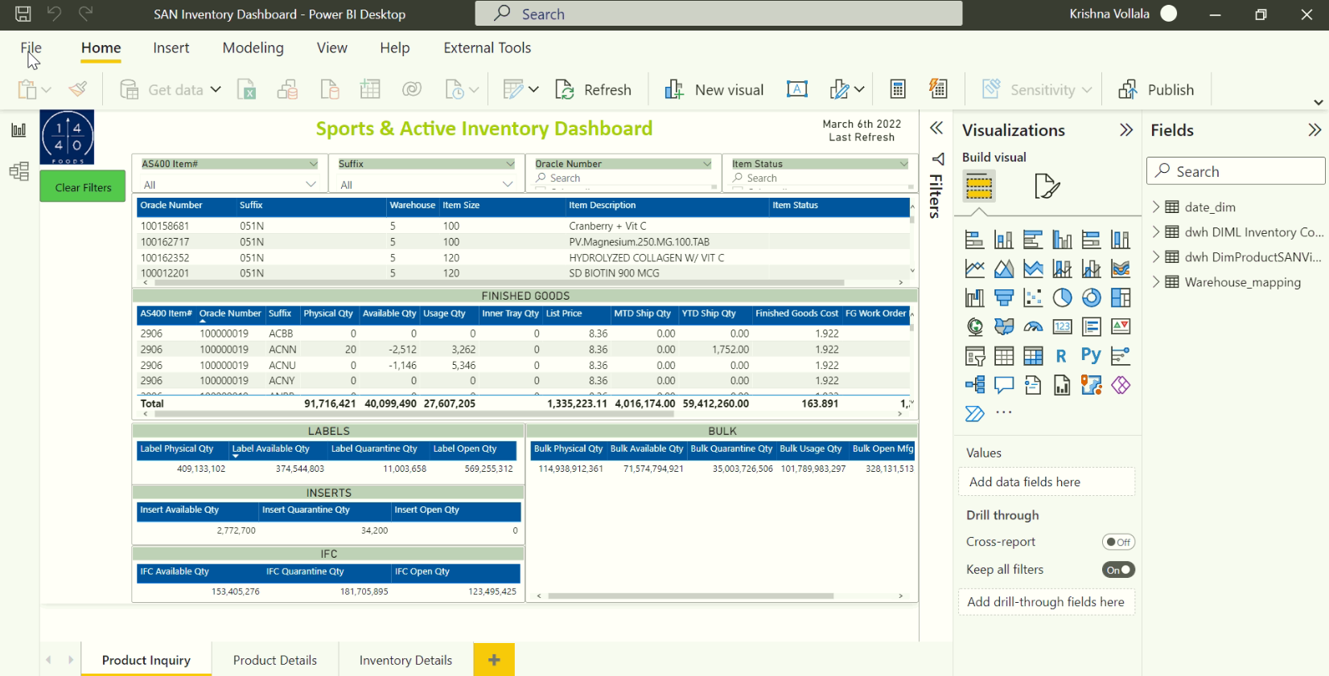

**Pages:**

Product Inquiry

Product Details

Inventory Details

### **SAN Revenue Recognition Dashboard**

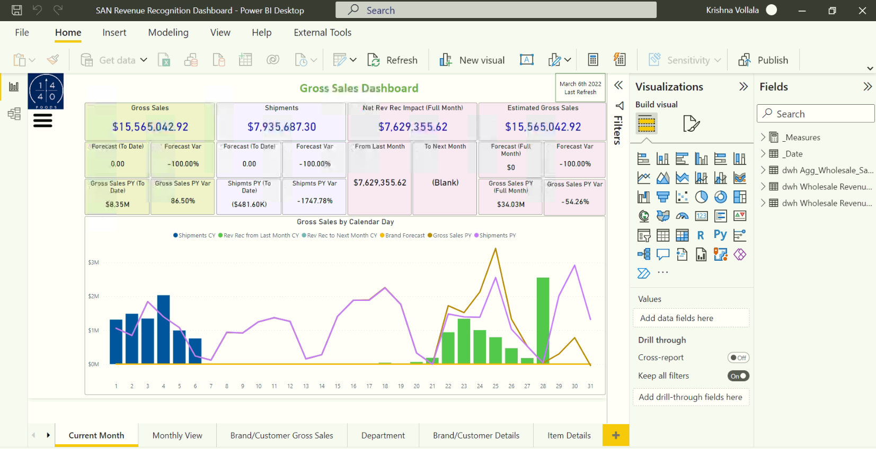

**Pages:**

Current Month

Monthly View

Brand/Customer Gross Sales

Department

Brand/Customer Details

Item Details

Gross Sales Raw-Daily

Additional Info

### **SAN TIM Dashboard**

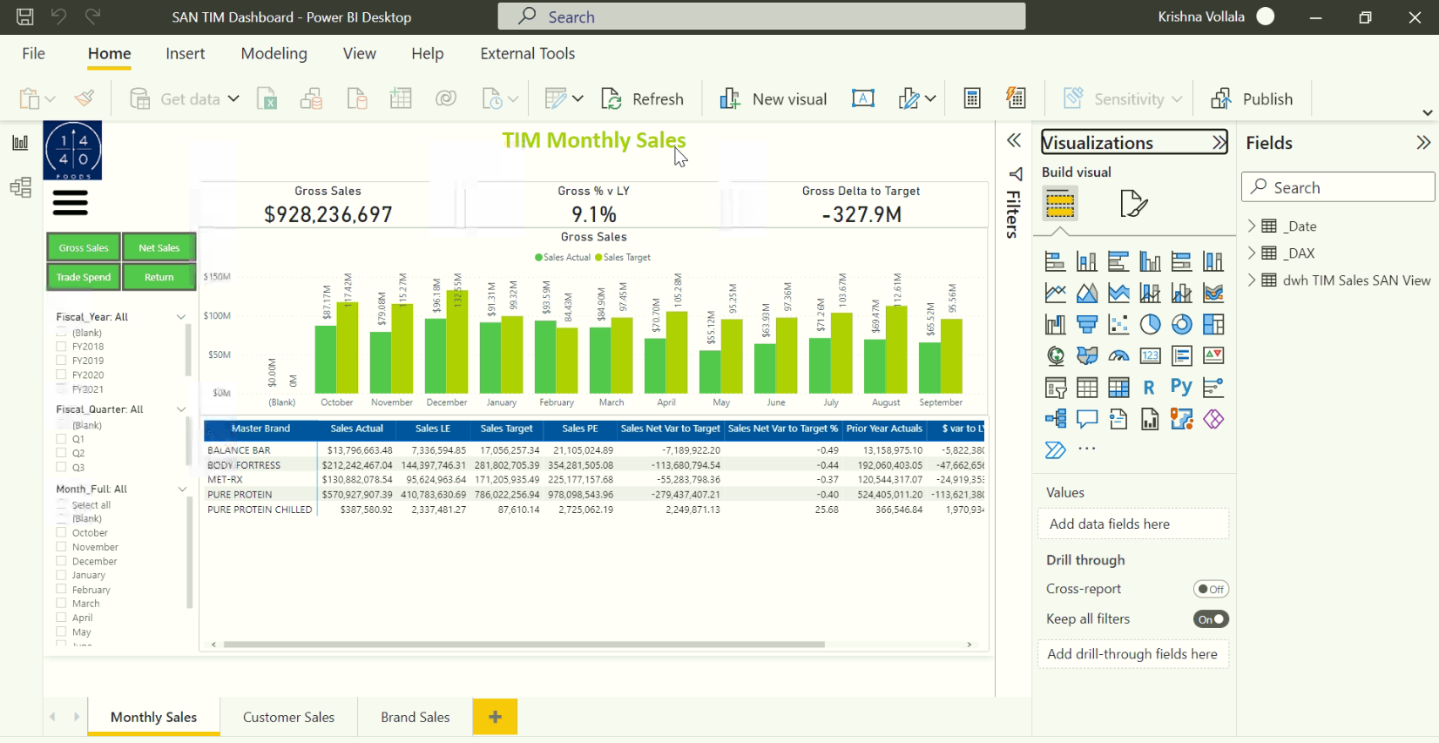

**Pages:**

Monthly Sales

Customer Sales

Brand Sales

### **SAN USA+CAD+Intl Wholesale Daily Shipments**

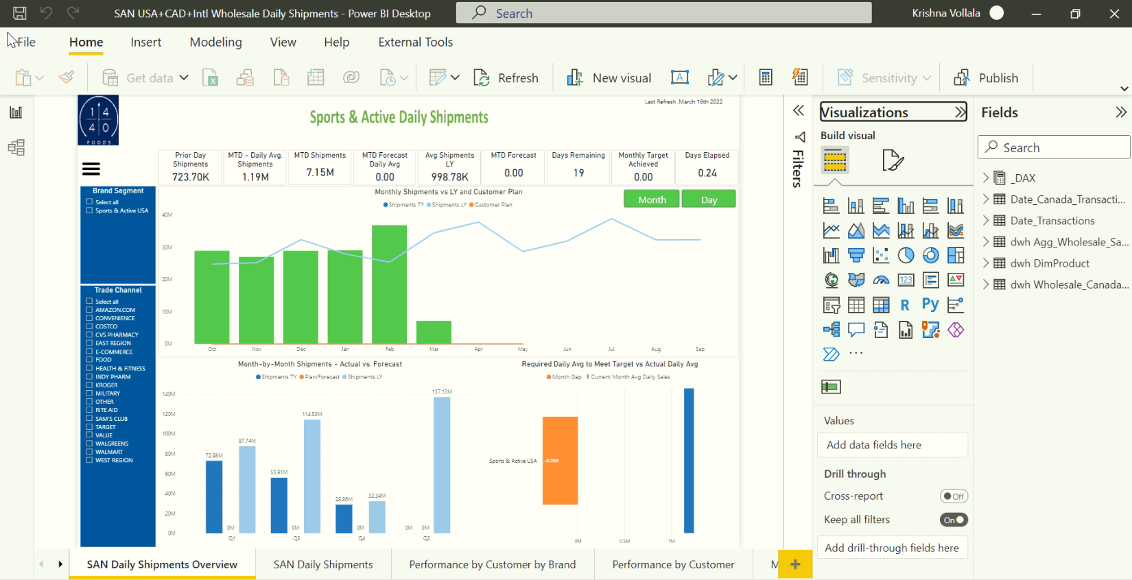

**Pages:**

SAN Daily Shipment Overview

SAN Daily Shipments

Performance by Customer by Brand

Performance by Customer

Monthly View

Shipment Custom Time Frame

Brand Segment Details

Trade Channel Details

Item Details

Shipment Deep Dive

Canada Details

Canada Details Monthly